AI - Powered Synthetic Scenario Generator

An IN-HOUSE PROJECT (7CS1900) REPORT

Submitted by

Spandana Basava Kulal – 2023BCSE07AED441
Akshata – 2023BCSE07AED389
Varshini J – 2023BCSE07AED403
Trisha S – 2023BCSE07AED522

In partial fulfilment for the award of the degree of

BACHELOR OF TECHNOLOGY
In
COMPUTER SCIENCE AND ENGINEERING (AIML)

Under the Supervision of

Dr. Saswati Debnath


ALLIANCE SCHOOL OF ADVANCED COMPUTING
ALLIANCE UNIVERSITY, BENGALURU
NOVEMBER - 2026

ABSTRACT

Network security is an important concern as computer networks face different types of cyberattacks. Machine learning can help identify these attacks, but when certain attack types have very few samples in a dataset, the model may find it difficult to detect them correctly. This project, titled “AI-Powered Synthetic Scenario Generator,” aims to address this problem by generating additional samples for rare attack categories using the UNSW-NB15 dataset.
The project focuses on the rare Worms attack category. To generate synthetic samples, the system selects existing Worms records and makes small changes to selected numerical features. This approach helps increase the number of samples available for training. A Random Forest model trained on the original dataset is then compared with a model trained using the augmented dataset.
A Streamlit dashboard is developed to present the results in an easy-to-understand format. It displays model performance metrics, confusion matrices, Worms-specific evaluation results, and the generated synthetic samples. The experimental results show a slight improvement after augmentation, with accuracy increasing from 74.96% to 74.97% and the weighted F1-score increasing from 78.35% to 78.40%.
Overall, this project demonstrates how synthetic data generation can be explored as a way to address class imbalance in network intrusion detection. The results also show that the improvement is small, leaving scope for further experimentation with data generation techniques.

TABLE OF CONTENTS

CHAPTER NO. | TITLE | PAGE NO.
 | ABSTRACT
 | INTRODUCTION | 4
 | 1.1 Background of the project
 | 1.2 Challenges in Network Intrusion Detection
 | LITERATURE REVIEW | 5-10
 | OBSERVATION FROM THE LITERATURE REVIEW | 11
 | LIMITATIONS OF THE LITERATURE REVIEW | 12
 | PROBLEM DEFINITION AND PROPOSED RESEARCH | 13-14
 | 5.1 Problem statement
 | 5.2 Proposed research
 | 5.3 Hardware requirements
 | 5.4 Software requirements
 | METHODOLOGY | 15-16
 | 6.1 System workflow
 | 6.2 Algorithm and Working
 | MODULE DESCRIPTION | 17
 | 7.1 Core modules
 | 7.2 Supporting modules
 | EXPERIMENTATION | 18
 | 8.1 Dataset and Input description
 | 8.2 Implementation and Testing
 | RESULT AND DISCUSSION | 19-21
10. | CONCLUSION AND FUTURE DIRECTIONS | 22
11. | REFERENCE | 23

- INTRODUCTION

  - Background of the Project
Network security is important for protecting computer systems and data from cyberattacks. Network Intrusion Detection Systems (NIDS) help identify suspicious activities by analysing network traffic. Machine learning techniques can improve intrusion detection by learning patterns from network data. However, some attack types have fewer samples than others, making them difficult for models to identify accurately.
The AI-Powered Synthetic Scenario Generator project uses the UNSW-NB15 dataset to address this class imbalance problem. It focuses on the rare Worms attack category and generates additional samples using perturbation-based sampling. A Random Forest model is then evaluated before and after data augmentation, and the results are displayed through a Streamlit dashboard.

1.2 Challenges in Network Intrusion Detection
A major challenge in network intrusion detection is the unequal distribution of attack samples. When rare attacks have very few records, a machine learning model may struggle to recognise them correctly. Generating additional samples can help, but the new records must contain reasonable feature values and should not negatively affect model performance.
This project investigates whether adding synthetic Worms attack samples can improve classification performance. The results are compared using evaluation metrics and confusion matrices to understand the effect of augmentation on both rare attack detection and overall model performance.

- LITERATURE REVIEW

S.NO | Paper Name | Author Name, Conference, Publication Year | Algorithm Used | Key Methodology | Limitation | Research Gap | How It Helps to Our Project
 | Network Intrusion Detection Based on Balancing Generative Adversarial Network | Yao Meng, Wenshu Zha — 2024 6th International Conference on Artificial Intelligence and Computer Applications (ICAICA) | BAGAN-BD, Autoencoder, Focal Loss, Gradient Penalty | Uses a Balancing GAN to generate attack data and address severe class imbalance. Evaluated on the UNSW-NB15 dataset. | Uses a complex multi-generator architecture and focuses on balancing several attack categories. | Targeted generation of synthetic samples specifically for the most underrepresented attack can be further explored. | Directly supports our UNSW-NB15 → rare attack → synthetic generation → IDS evaluation approach.
 | Enhancing Autonomous Intrusion Detection System with Generative Adversarial Networks | Kevin Kostage, David West, Tim Meinert, Chengyi Qu, Prasad Calyam, Luca Mazzola — 2024 IEEE 20th International Conference on e-Science | WGANGP, CGAN, CTGAN, CWGANGP | Generates synthetic data using different GAN variants and compares GAN-based augmentation with SMOTE and Random Oversampling using accuracy, precision, recall and F1-score. | Multiple GAN models increase computational complexity and training time. | A focused framework for identifying a rare attack and generating only the required synthetic samples can be investigated. | Directly supports our CTGAN selection and our Real-only vs Real+Synthetic experiment.
 | KiNETGAN: Enabling Distributed Network Intrusion Detection through Knowledge-Infused Synthetic Data Generation | Anantaa Kotal, Brandon Luton, Anupam Joshi — 2024 IEEE 44th International Conference on Distributed Computing Systems Workshops (ICDCSW) | Knowledge-Infused GAN (KiNETGAN) | Uses domain knowledge with GANs to generate realistic synthetic network activity while addressing privacy and class-imbalance issues. | Focuses on distributed IoT/CPS environments rather than specifically targeting a rare UNSW-NB15 attack. | Targeted tabular synthetic generation for specific minority attack categories can be explored  . | Supports the concept of realistic synthetic network-data generation and evaluating its usefulness for IDS.
 | AI-Driven Synthetic Test Data and Scenario Generation via GAN-LLM Integration: A Modular Approach for Web Application Testing | Miraç Emektar, Fatih Mehmet Harmancı, Aysun Güran, Berat Karadavut, Günay Kırmızı, Berkay Öztürk, Ata Emir Karamuk, Mert Güven — 2025 10th International Conference on Computer Science and Engineering (UBMK) | LLaMA4, CTGAN, SeqGAN, Selenium | Uses LLaMA4 for semantic extraction, CTGAN for realistic tabular data, and SeqGAN for ordered interaction scenarios. | Designed for web-application testing rather than network intrusion detection and does not use UNSW-NB15. | The AI-driven scenario-generation concept can be adapted to cybersecurity and network-intrusion scenarios. | Highly relevant to our project title “AI-Powered Synthetic Scenario Generator.” It supports AI + synthetic data + scenario generation.
 | An Enhanced AI-Based Network Intrusion Detection System Using Generative Adversarial Networks | Cheolhee Park, Jonghoon Lee, Youngsoo Kim, Jong-Geun Park, Hyunjin Kim, Dowon Hong — IEEE Internet of Things Journal, 2023 | Wasserstein GAN, Autoencoder, Reconstruction Error | Generates plausible synthetic minority-attack traffic using GANs and combines it with autoencoder-based intrusion detection. | The framework is more complex than a basic CTGAN augmentation pipeline and does not specifically focus on automatic rare-class selection. | A simpler targeted CTGAN approach with explicit real-vs-synthetic validation can be explored  . | Strong evidence that GAN-generated minority samples can improve IDS, supporting our central project idea.
 | AE-Multi-WGAN: A Robust Multi-Attack Detection IDS for Imbalanced Datasets | Ishfaq Bashir, Anjali Agarwal, Kuljeet Kaur — 2025 IEEE Global Communications Conference (GLOBECOM) | AutoEncoder + Multi-WGAN | Uses an ensemble AutoEncoder Multi-WGAN to generate synthetic attack samples and improve IDS performance on imbalanced datasets including UNSW-NB15. | Ensemble architecture increases computational and implementation complexity. | A comparatively lightweight CTGAN-based rare-attack augmentation framework can be investigated. | Provides a recent GAN-based benchmark for synthetic-data generation and IDS performance comparison.
 | A Cost-Sensitive Machine Learning Model With Multitask Learning for Intrusion Detection in IoT | Akbar Telikani, Nima Esmi Rudbardeh, Shiva Soleymanpour, Asadollah Shahbahrami, Jun Shen, Georgi Gaydadjiev, Reza Hassanpour — IEEE Transactions on Industrial Informatics, 2024 | Autoencoder + Cost-Sensitive SVM + Multitask Learning | Addresses low-frequency and unknown intrusions using cost-sensitive and multitask learning. Evaluated on UNSW-NB15 and BoT-IoT. | Improves minority detection without generating synthetic data and uses a relatively complex architecture. | Synthetic data generation can be investigated as an alternative/complementary approach for rare attacks. | Provides strong problem justification for rare/low-frequency attacks in our project.
 | Enhanced Network Intrusion Detection Using a Hybrid CNN-LSTM Approach on the UNSW-NB15 Dataset | Zareen Tasnim Pear, Hafsa Binte Kibria — 2024 21st International Conference on Electrical Engineering, Computing Science and Automatic Control (CCE) | CNN + LSTM | Uses a hybrid CNN-LSTM model for binary and multiclass intrusion detection using UNSW-NB15. Evaluates accuracy, precision, recall and F1-score. | Focuses on classification and does not address synthetic-data generation for minority classes. | Synthetic-data augmentation can be combined with IDS classifiers to improve rare-attack detection. | Provides a UNSW-NB15 classification baseline and supports our evaluation metrics.
 | Network Anomaly Detection for Intrusion Detection Systems Using Q-Learning and Deep Q-Learning: A Reinforcement Learning Approach | Adhitama Wichaksono, Parman Sukarno, Aulia Arif Wardana — 2025 IEEE 9th International Conference on Software Engineering & Computer Systems (ICSECS) | Q-Learning, Deep Q-Learning, SMOTE-Tomek | Uses reinforcement learning for adaptive IDS. Uses UNSW-NB15 and simulates zero-day attacks by excluding Fuzzers and Reconnaissance from training. | Focuses on adaptive classification rather than synthetic attack generation. | Synthetic generation could be used to create additional rare or unseen attack scenarios before classification. | Supports our focus on rare/unseen attack scenarios and emphasizes evaluation using unseen data.
 | Intrusion Detection System Based on Machine Learning Techniques: A Survey | Omar I. Sheet, Laheeb Mohammad Ibrahim — 2022 2nd International Conference on Advances in Engineering Science and Technology (AEST) | SVM, Random Forest, Decision Tree, Naïve Bayes, DNN, XGBoost, DBN, ANN | Reviews ML-based intrusion-detection algorithms and datasets including UNSW-NB15, comparing approaches using performance metrics. | Mainly focuses on ML/DL classification and does not deeply investigate GAN-based synthetic data generation. | Integration of synthetic-data generation with ML-based IDS remains an important direction. | Provides the general IDS background and supports using classifiers such as Random Forest in our experiment.

- OBSERVATIONS FROM THE LITERATURE REVIEW

The following observations were made from the reviewed research papers:
- Use of Machine Learning: Several studies use machine learning algorithms such as Random Forest, SVM, Decision Trees, and deep learning models for network intrusion detection.
- Synthetic Data Generation: Multiple papers explore GAN-based techniques to generate synthetic attack samples and address class imbalance.
- Use of UNSW-NB15 Dataset: Several reviewed studies use the UNSW-NB15 dataset to evaluate intrusion detection methods.
- Importance of Rare Attack Detection: The reviewed research highlights the difficulty of detecting attack categories with fewer training samples.
- Different Data Balancing Techniques: Researchers explore methods such as GAN variants, SMOTE, and random oversampling to improve the representation of minority classes.
- Model Evaluation: Accuracy, precision, recall, and F1-score are commonly used to evaluate intrusion detection performance.
- Need for Practical Approaches: The reviewed studies suggest the value of exploring simpler synthetic data generation methods and measuring their effect on classification performance.
Based on these observations, our project focuses on generating additional samples for the rare Worms attack category and comparing Random Forest performance before and after augmentation.

- LIMITATIONS OF THE LITERATURE REVIEW
The reviewed papers have some limitations and areas that require further investigation:
- High Computational Requirements: Some GAN-based approaches use complex architectures that may require more computing resources and training time.
- Focus on Specific Methods: Several studies concentrate on particular algorithms or network environments, which may limit their direct applicability to other settings.
- Limited Focus on Individual Rare Attacks: Not all reviewed studies specifically focus on generating samples for the rare Worms category in UNSW-NB15.
- Quality of Synthetic Samples: Increasing the number of training samples does not necessarily guarantee that the generated records are realistic or useful for classification.
- Need for Performance Comparison: The effect of synthetic data augmentation needs to be measured by comparing model performance before and after adding synthetic samples.
- Further Validation Required: Additional experiments are needed to understand how different generation techniques affect rare attack detection and overall classification performance.
Based on these limitations, our project uses perturbation-based sampling to generate additional Worms records and compares the results of Random Forest models trained with and without augmentation. The approach provides a simple way to study the effect of synthetic samples, although further testing is needed to establish their quality and general usefulness.

5. PROBLEM DEFINITION AND PROPOSED RESEARCH
5.1 Problem Statement
Network intrusion detection models may struggle to identify rare attacks when the training dataset contains very few samples for those categories. This class imbalance can affect the model's ability to recognise minority attacks correctly. In this project, the focus is on the rare Worms attack category in the UNSW-NB15 dataset. The main problem is to determine whether generating additional synthetic Worms samples can improve Random Forest classification performance.

5.2 Proposed Research
The project proposes a simple approach to address class imbalance using perturbation-based sampling. Existing Worms records are selected, and small changes are applied to selected continuous features to generate additional synthetic samples. These samples are added to the training data, and a Random Forest model trained on the augmented dataset is compared with a model trained on the original data.
The system also includes a Streamlit dashboard that displays evaluation metrics, confusion matrices, Worms-specific results, and synthetic samples. This helps users understand the effect of augmentation on model performance.

5.3 Hardware Requirements
The project can be developed and tested on a standard computer with the following recommended configuration:
- Processor: Intel Core i3 or equivalent and above
- RAM: 8 GB or more
- Storage: At least 5 GB of available space
- Operating System: Windows, Linux, or macOS
- Internet Connection: Required for downloading datasets and installing libraries, and accessing the deployed dashboard
5.4 Software Requirements
The following software and tools are used in the project:
- Programming Language: Python
- Dataset: UNSW-NB15
- Machine Learning Library: Scikit-learn
- Data Processing Libraries: Pandas and NumPy
- Dashboard Framework: Streamlit
- Data Visualisation: Matplotlib
- Development Environment: Visual Studio Code or Jupyter Notebook
- Version Control: Git and GitHub

6. METHODOLOGY

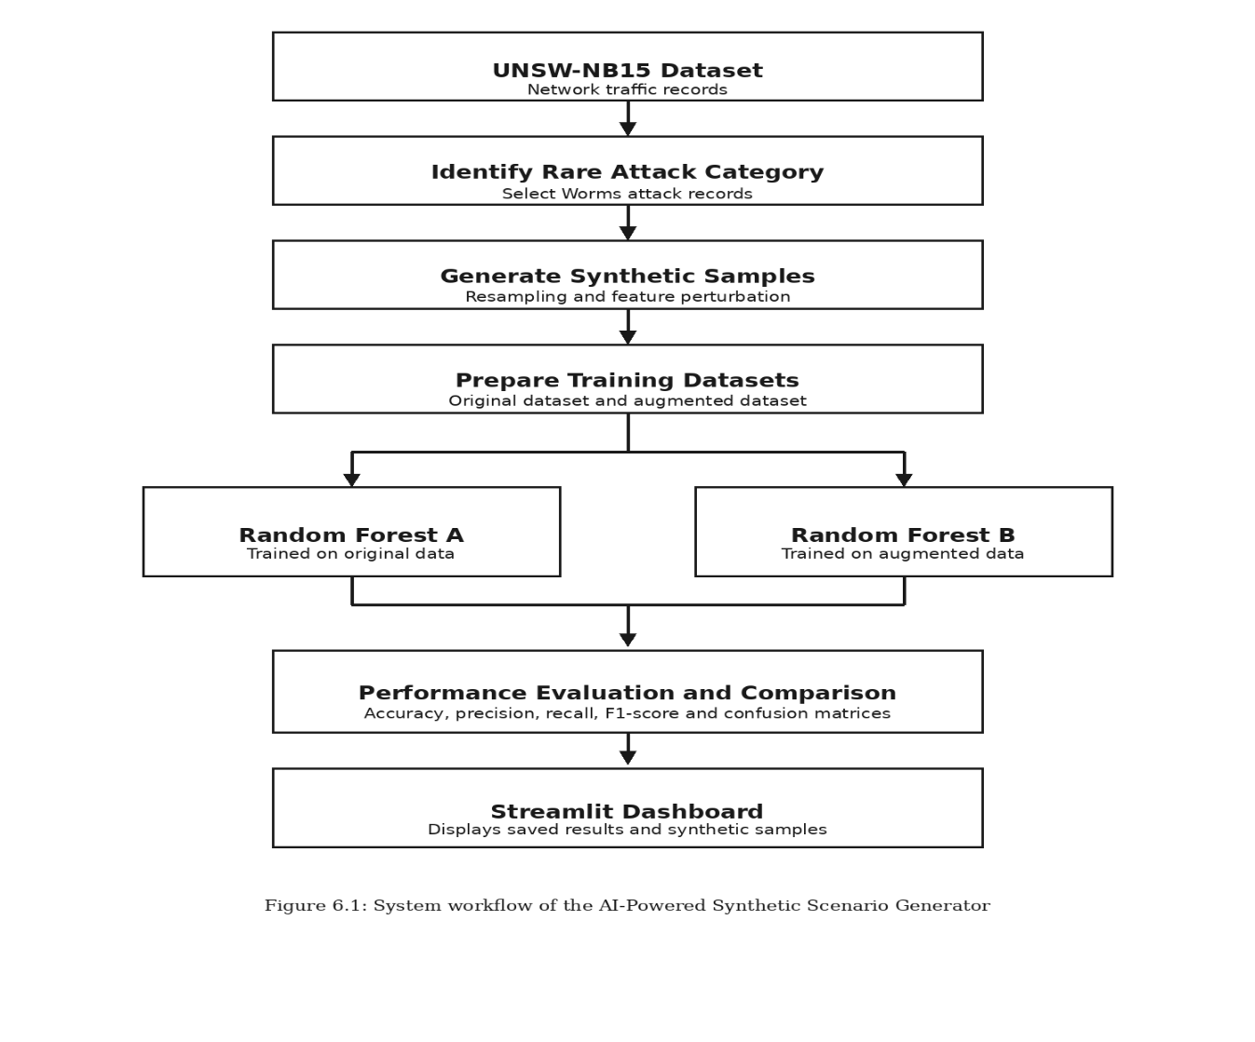
6.1 System Workflow

The system follows a step-by-step process to generate synthetic samples and evaluate their effect on network intrusion detection.
1. Dataset selection: The UNSW-NB15 dataset provides the network traffic records used in the experiment.
2. Rare attack identification: The Worms attack category is selected because it is underrepresented in the dataset.
3. Synthetic sample generation: Existing Worms records are resampled, and small changes are applied to selected continuous features to generate additional samples.
4. Dataset preparation: The original training data and the augmented training data are prepared for comparison.
5. Model training: Two Random Forest models are evaluated: one trained using the original data and the other using the augmented data.
6. Performance comparison: Their evaluation metrics and confusion matrices are compared to study the effect of synthetic data augmentation.
7. Dashboard: The Streamlit dashboard displays the saved model results, Worms-specific metrics, and synthetic samples. It does not retrain the models.

6.2 Algorithm and Working
The project uses perturbation-based sampling to generate additional records for the rare Worms attack category. Instead of generating samples entirely from scratch, it uses existing records as the starting point and introduces small changes to selected numerical features.

The working process is as follows:
1. Load the UNSW-NB15 dataset and identify the Worms attack records.
- Select existing Worms records for synthetic sample generation.
- Apply small perturbations to selected continuous features to create additional records.
- Prepare the augmented training dataset.
- Train and evaluate a Random Forest model using the original training data and compare it with the model trained using the augmented data.
- Compare the evaluation metrics to observe whether augmentation improves classification performance.
- Display the results through the Streamlit dashboard.

The dashboard presents the saved results rather than training the models again. In the experiment, the original model achieved 74.96% accuracy and a weighted F1-score of 78.35%. After augmentation, accuracy increased to 74.97% and the weighted F1-score to 78.40%. These results show a small improvement in overall performance.

7. MODULE DESCRIPTION

7.1 Core Modules
1. Dataset Handling Module - This module uses the UNSW-NB15 dataset and identifies records belonging to the Worms attack category. These records are used as the basis for generating additional synthetic samples.
2. Synthetic Sample Generation Module - This module generates additional Worms records using perturbation-based sampling. Existing records are resampled, and small changes are applied to selected continuous features to create synthetic samples.
3. Model Evaluation Module - This module compares the performance of two Random Forest models: one trained on the original dataset and another trained on the augmented dataset. Evaluation metrics and confusion matrices are used to understand the effect of synthetic data augmentation.

7.2 Supporting Modules
1. Data Validation Module - This module performs basic checks on the generated samples, including checking for missing values and negative values in selected continuous features. These checks help identify some invalid values but do not guarantee that all synthetic samples are realistic.
2. Visualisation Module - This module presents model evaluation results through charts, confusion matrices, and Worms-specific performance metrics. It helps users understand the results without examining raw data manually.
3. Streamlit Dashboard Module - The dashboard provides a user-friendly interface with sections for the main dashboard, synthetic samples, model evaluation, and downloading results. Users can view saved evaluation outputs and download available result files.
4. Results Export Module - This module uses saved output files, including evaluation predictions, synthetic Worms samples, and overall model metrics. These files support result presentation and comparison through the dashboard.

8. EXPERIMENTATION

8.1 Dataset and Input Description
The project uses the UNSW-NB15 dataset, which contains network traffic records representing normal activities and different types of attacks. It is used to study network intrusion detection and evaluate machine learning models.
This project focuses on the Worms attack category, which is treated as a rare class for the experiment. Existing Worms records are used to generate additional synthetic samples through perturbation-based sampling. Small changes are applied to selected continuous features to increase the number of samples available for training.
The generated samples are added to the training data, and two Random Forest models are compared: one trained on the original dataset and another trained on the augmented dataset. The input records contain network traffic features, while the model predicts the corresponding traffic or attack category.

8.2 Implementation and Testing
The project uses Python to generate synthetic Worms attack samples through perturbation-based sampling and compare two Random Forest models. Basic validation checks are performed, and the results are displayed using a Streamlit dashboard.
The original model achieved 74.96% accuracy and a 78.35% weighted F1-score, while the augmented model achieved 74.97% accuracy and a 78.40% weighted F1-score. The results show a slight improvement after augmentation. The dashboard also allows users to view evaluation results, synthetic samples, and download output files.

9. RESULTS AND DISCUSSION

  - Overall Model Performance Comparison
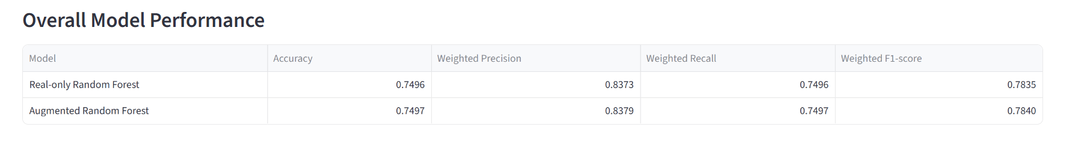

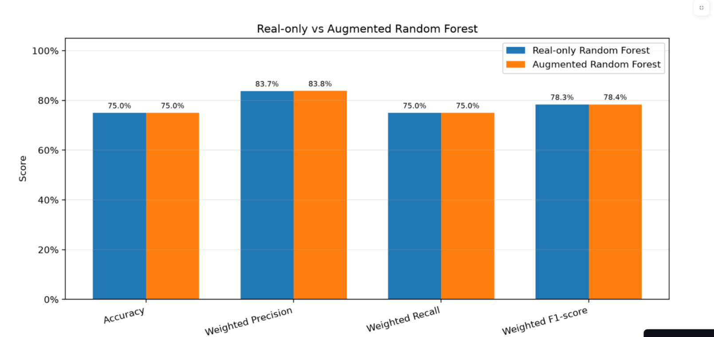
Overall Performance Comparison

The proposed model shows a slight improvement in all four overall performance metrics after synthetic data augmentation. However, the improvement is small, so the results do not indicate a major change in overall classification performance.

9.2 Worms Attack Detection Comparison
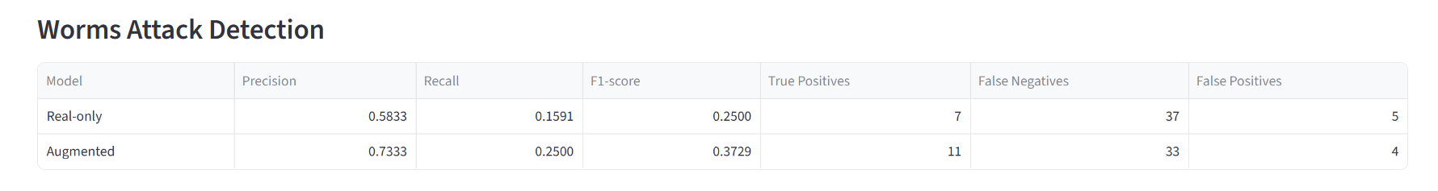
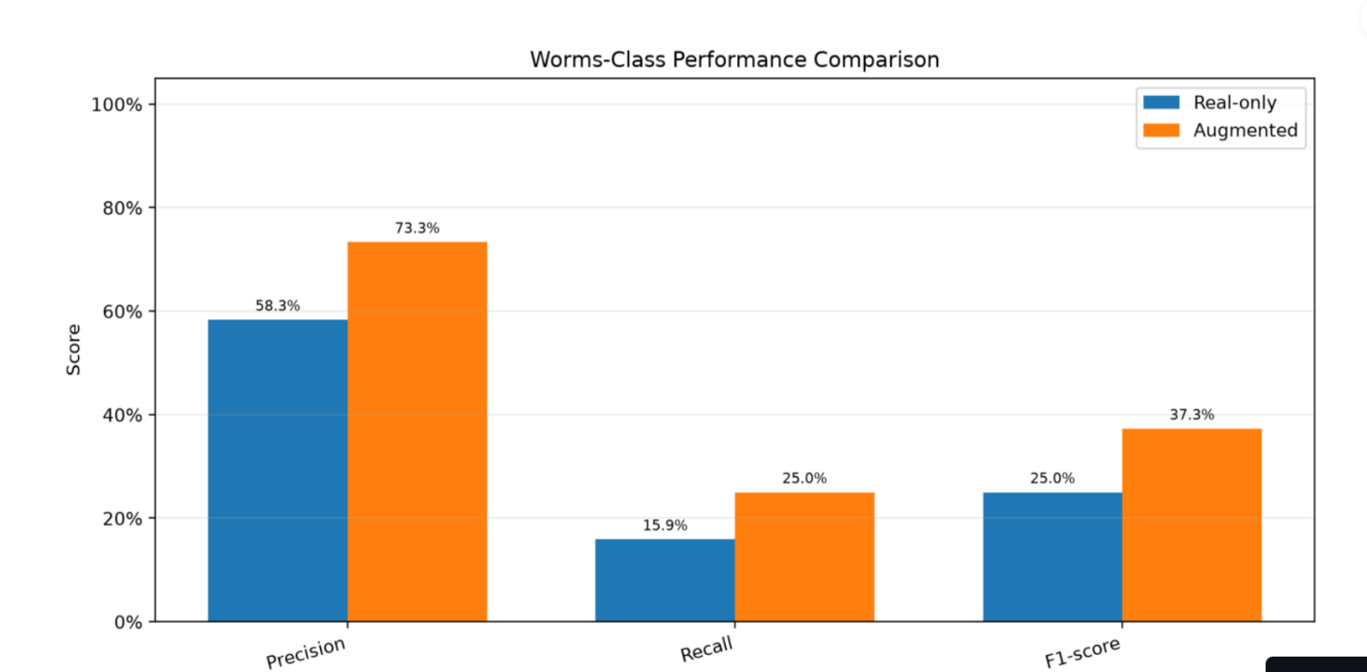

After augmentation, the model correctly detected 11 Worms samples compared with 7 in the existing model. Recall increased from 15.91% to 25.00%, while the F1-score increased from 25.00% to 37.29%. This suggests that synthetic augmentation helped the model identify more Worms attacks, although many attacks were still missed.

  - Confusion Matrix Comparison
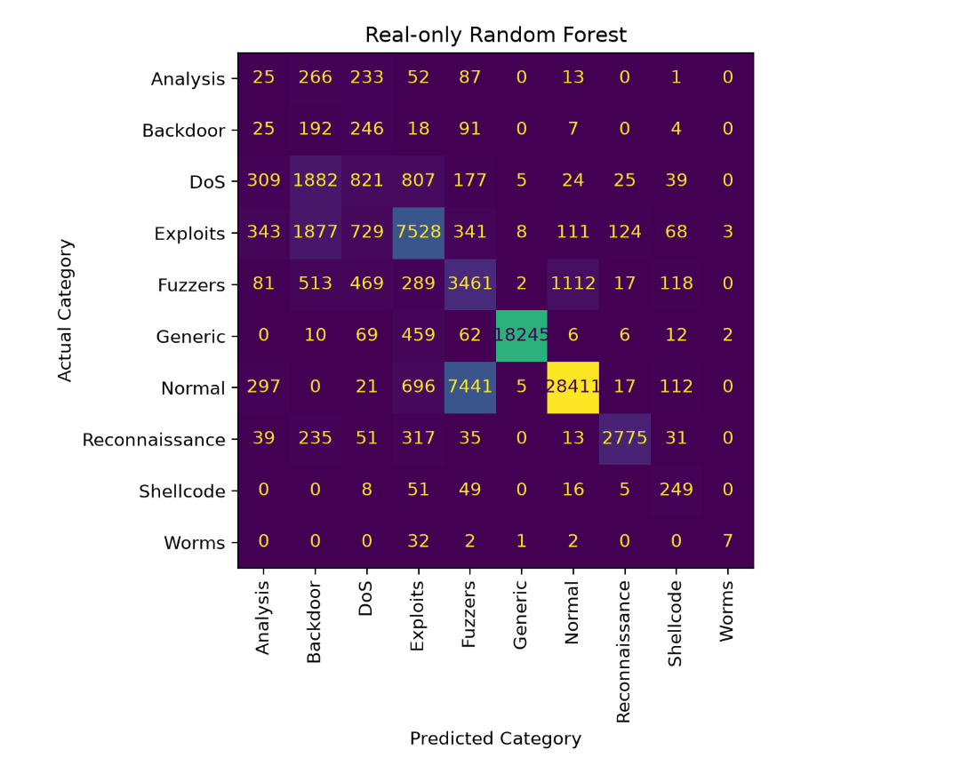
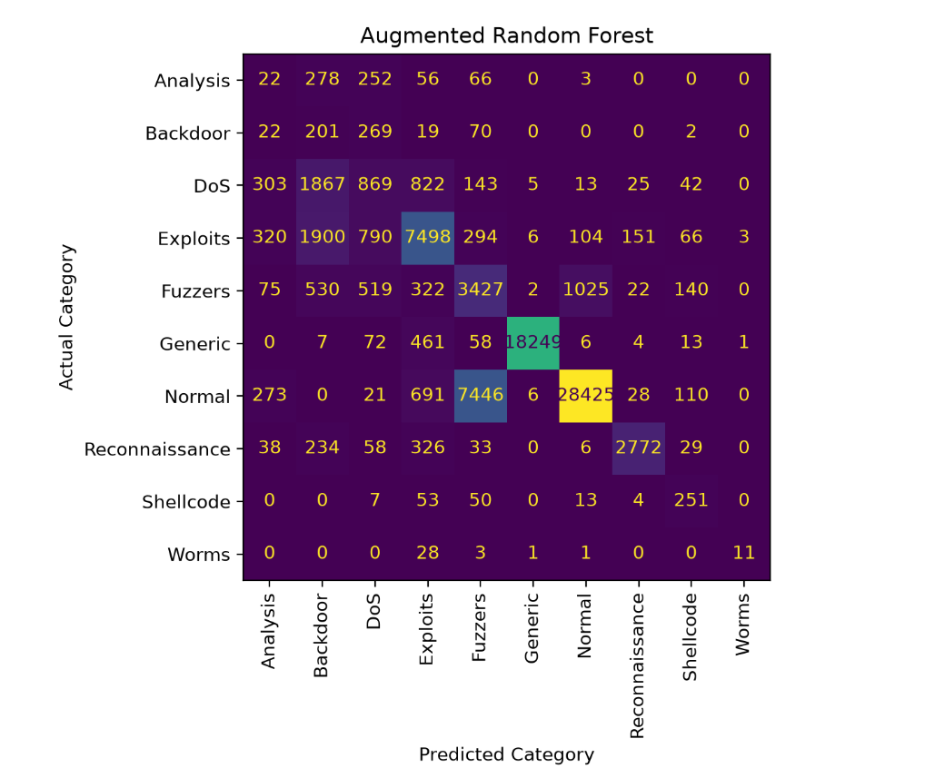
Above fig compares the confusion matrices of the Real-only Random Forest and Augmented Random Forest models across ten network traffic categories. The diagonal values represent correctly classified records, while the other values indicate misclassifications.
For the Worms category, the existing model correctly classified 7 records, whereas the proposed model correctly classified 11 records. The number of false negatives decreased from 37 to 33, indicating that the augmented model detected more Worms attacks. However, some records from other attack categories were still misclassified.
Overall, the confusion matrices show that synthetic data augmentation improved the detection of the rare Worms category, although further improvement is needed to reduce classification errors.

10. CONCLUSION AND FUTURE DIRECTIONS

Conclusion
The project successfully generated 500 synthetic Worms records using perturbation-based sampling and compared the performance of two Random Forest models. The augmented model improved Worms detection, increasing the F1-score from 25.00% to 37.29%. However, the improvement in overall accuracy was small. The results show that synthetic data augmentation can help address rare attack detection, but further improvements are needed.

Future Directions
- Explore advanced synthetic data generation techniques.
- Improve detection of rare network attacks.
- Perform more extensive validation of synthetic samples.
- Evaluate additional machine learning models.
- Test the approach on other network intrusion datasets.

11. REFERENCES

- Y. Meng and W. Zhao, “Network Intrusion Detection Based on Balancing Generative Adversarial Network,” ICAICA, 2024.
- K. Kostage, D. West, T. Meinert, C. Qu, and P. Calyam, “Enhancing Autonomous Intrusion Detection System with Generative Adversarial Networks,” IEEE e-Science, 2024.
- A. Kotal, B. Luton, and A. Joshi, “KiNETGAN: Enabling Distributed Network Intrusion Detection through Knowledge-Infused Synthetic Data Generation,” ICDCSW, 2024.
- C. Park et al., “An Enhanced AI-Based Network Intrusion Detection System Using Generative Adversarial Networks,” IEEE Internet of Things Journal, 2023.
- I. Bashir, A. Agarwal, and K. Kaur, “AE-Multi-WGAN: A Robust Multi-Attack IDS for Imbalanced Datasets,” IEEE GLOBECOM, 2025.
- O. I. Sheet and L. M. Ibrahim, “Intrusion Detection System Based on Machine Learning Techniques: A Survey,” AEST, 2022.
- UNSW Canberra, “The UNSW-NB15 Dataset.” Available: https://research.unsw.edu.au/projects/unsw-nb15-dataset
- Scikit-learn, “RandomForestClassifier Documentation.” Available: https://scikit-learn.org/stable/modules/generated/sklearn.ensemble.RandomForestClassifier.html
- Streamlit, “Streamlit Documentation.” Available: https://docs.streamlit.io/

